
DEPARTMENT OF INFORMATION TECHNOLOGY

Synopsis of Major Project On

Explainable AI and LLM-Based Causal Analysis of Weather-Driven Electricity Load

Prepared By:
Amey Patil (B-15)
Tanisha Rathi (B-62)
Siddhesh Pandey (B-3)
Harsh Parmar (B-10)

Under the guidance of:
Dr. Radhika Kotecha,
Professor and Head of IT Department

Department of Information Technology
Academic Year: 2025-2026
Autonomy Syllabus Scheme-III (2025-26) - SEMESTER VI (TY - IT)
CERTIFICATE

This is to certify that following students:
Roll No. / Seat No.
Amey Patil 15
Tanisha Rathi 62
Siddhesh Pandey 03
Harsh Parmar 10
have submitted Major Project-A Report on “Explainable AI and LLM-Based Causal Analysis of Weather-Driven Electricity Load” as the partial fulfillment for the requirement of Final Year of Engineering (6th Semester) in L.Y. - Information Technology under my guidance during the academic year 2025-2026.

Dr. Radhika Kotecha | Dr. Radhika Kotecha
Project Guide | Head of Department
Professor | Professor
Department of Information Technology | Department of Information Technology

Date of Examination: _________________

Signature of Internal Examiner Signature of External Examiner

Table of Contents

Acknowledgement | i
Abstract | ii
Introduction | 1
Literature Review | 4
Proposed system | 14
Implementation Details and Results | 16
Result and Discussion | 21
Conclusion and Future Work | 27
Reference | 29

Acknowledgement
We would like to express our sincere gratitude to our Project Guide Dr. Radhika Kotecha, Head of the Department of Information Technology, for her continuous support, valuable guidance, and encouragement throughout the development of this project. Her insights and expertise played a crucial role in shaping the direction and quality of our work.
We extend our heartfelt thanks to Mrs. Nasim Shah, Major Project Coordinator, for her constant motivation and support during the course of this project.
We would also like to express our sincere appreciation to Dr. Vivek Sunnapwar, Principal, for his support and for providing the institutional resources required for the successful completion of this project.
Finally, we would like to thank all those who directly or indirectly contributed to the successful completion of this project.

Abstract
Efficient power system management depends on accurate electricity load analysis, particularly in weather-sensitive environments. While traditional machine learning models achieve high predictive accuracy, they often lack the interpretability required for reliable real-world decision-making. This study proposes an integrated framework that bridges this gap by combining Explainable Artificial Intelligence (XAI), Causal Inference, and traditional statistical modeling to analyze the impact of weather variables specifically temperature and relative humidity on power demand.
To ensure both global and local interpretability, the framework utilizes SHAP and LIME techniques. Moving beyond simple correlation, the system incorporates the EconML library, employing Double Machine Learning (DML) and Causal Forests to estimate Average Treatment Effects (ATE) and Heterogeneous Treatment Effects (HTE). This approach allows for a granular understanding of how weather impacts vary across different seasonal and temporal conditions. A Multiple Linear Regression (MLR) model serves as a baseline for performance comparison.
The models were trained and validated using two annual cycles of time-series data. Results indicate that the EconML-based causal framework significantly outperforms the traditional MLR baseline. The causal model achieved a Mean Absolute Percentage Error (MAPE) of 1–1.2%, a substantial improvement over the 12–16% MAPE produced by the MLR. Findings confirm that temperature is the primary driver of load variations, with humidity playing a secondary role. By integrating causal reasoning with XAI, this framework provides a transparent, scalable, and highly accurate solution for future smart grid applications and energy management systems, offering deeper insights into the underlying drivers of demand behavior.

Chapter 1
Introduction
Modern electrical power systems are growing in complexity, where external conditions such as weather have a strong influence on demand behavior. Factors like temperature, humidity, and time of day significantly shape electricity consumption patterns across different operational scenarios, as they directly affect user usage habits and system load variations. Studying these relationships is important for improving electricity load forecasting and system reliability [1].

In recent years, electricity load forecasting has been extensively explored using machine learning and deep learning techniques due to their ability to model nonlinear and complex patterns from historical datasets. Although these methods deliver high prediction accuracy, they generally depend on correlation-based learning and do not explicitly reveal causal relationships between variables [2]. This reduces their effectiveness in explaining why changes in electricity demand occur.

In practical weather-dependent load environments, variables such as temperature and humidity often exhibit strong interdependence with time-based factors like hourly and seasonal variations. This overlap can introduce confounding effects, where predictive models mistakenly associate load changes with temporal features rather than actual weather conditions [3]. Hence, there is a growing need for approaches that can clearly distinguish genuine causal influences from misleading correlations.

To improve model interpretability, Explainable Artificial Intelligence techniques such as SHAP and LIME are commonly applied in energy-related forecasting studies. SHAP evaluates the contribution of each feature using a game-theoretic approach, while LIME explains individual predictions by approximating complex models locally [4]. However, these methods primarily focus on explaining model outputs rather than identifying underlying causal mechanisms.

To overcome these limitations, causal inference approaches are increasingly adopted in electricity demand analysis. These methods aim to estimate the true effect of weather-related variables on electricity load while accounting for confounding influences, thereby improving the reliability of interpretations derived from predictive systems [5]. When integrated with explainable AI techniques, they enhance both transparency and understanding of how electricity demand is influenced by environmental factors.

  - Rationale
Fluctuating weather conditions significantly impact power demand, making accurate analysis essential for modern power systems. Variations in temperature, humidity, and seasonal patterns lead to changes in electricity usage across different sectors. Understanding these variations helps improve demand estimation, forecasting accuracy, and system planning.
With the increasing focus on sustainable and optimized resource utilization, there is a growing need to analyse power demand beyond simple pattern recognition. Many traditional approaches primarily identify relationships within data but fail to clearly explain the reasons behind changes in demand. This limitation can reduce the reliability of planning and decision-making in complex and dynamic environments.
To address these challenges, causal and explainable methods are used to identify key drivers of demand and improve model transparency. These approaches support better decision-making and efficient power system management.
  - Objectives
The research aims to achieve the following objectives:
- To review and analyze existing studies on the relationship between electricity load and weather variables, focusing on the impact of temperature and humidity using statistical, machine learning, causal inference, and explainable AI techniques.
- To design and implement a framework for analyzing electricity load variations by applying statistical and machine learning models to estimate the effects of temperature and humidity on load.
- To develop an integrated system combining causal inference, explainable AI, and Large Language Models for generating human-understandable explanations of load variations.
- To improve the accuracy and interpretability of load prediction and causal analysis for better decision-making.
  - Scope
This study focuses on analyzing the relationship between weather conditions and electricity load using data-driven approaches. It examines key variables such as temperature and humidity to understand how they influence power demand patterns. The analysis incorporates statistical techniques, machine learning models, causal inference methods, and explainable AI approaches to identify meaningful patterns, measure relationships, and estimate the impact of weather variations on electricity load behavior.

The work is designed to support continuous analysis using live data, enabling better understanding of how electricity load responds to changing weather conditions over time. It emphasizes model development, evaluation, and interpretation of results to generate reliable and actionable insights for improved decision-making in demand analysis

  - Research Timeline
The project covers literature review followed by implementation of a framework for analysing
electricity load using machine learning and causal methods:
Table 1.4
Activities | Months
Activities | January-February 2026 | March-  April 2026 | July-August 2026 | September-October 2026
Literature Review & Analysis
Framework Design & ML Models
Causal + XAI + LLM Integration
Model Optimization & Interpretation
Paper & Report Writing
Table 1.4 presents the phased execution of the project, outlining the sequence of key activities undertaken. It highlights the transition from initial research to framework implementation of electricity load behaviour.
1.5 Organization
The report is organized into different chapters to present the work in a clear and structured manner. Chapter 2 covers existing studies on the relationship between weather conditions and electricity load along with related analytical techniques. Chapter 3 explains the overall framework and methodology used for analyzing weather-driven variations in power demand. Chapter 4 describes the implementation process, including data preprocessing, model development, and application of statistical, machine learning, causal, and explainable AI techniques. Chapter 5 presents the results and discussion of model performance and findings, while Chapter 6 provides the final summary of key insights and overall outcomes, and Chapter 7 includes all the references used.

Chapter 2
Literature Review
Explainable Artificial Intelligence (XAI) has gained significant importance due to the increasing use of complex machine learning models such as deep neural networks, which often act as “black boxes.” Traditional models lack transparency, making it difficult for users to understand how decisions are made. To address this, various XAI techniques have been proposed.
2.2 Background
Electricity load forecasting has traditionally focused on improving prediction accuracy using machine learning and deep learning models. While these models effectively capture complex patterns in historical data, they mainly learn correlations rather than true cause-and-effect relationships. In weather-driven electricity demand, variables like temperature and humidity are strongly correlated with time (e.g., hour of the day), which can lead models to misattribute load changes to time instead of actual weather impact. Therefore, there is a need for approaches that not only predict load accurately but also explain the underlying reasons behind these changes.
To improve interpretability, Explainable Artificial Intelligence (XAI) methods such as SHAP and LIME are widely used. SHAP assigns contribution values to each feature based on game theory, providing both global and local explanations of model predictions [4]. LIME explains individual predictions by approximating the model locally with a simpler interpretable model [4]. However, both SHAP and LIME explain model behavior rather than true causal relationships, making them limited to correlation-based insights.
To address this limitation, causal inference methods such as Double Machine Learning (DML) are employed to estimate causal effects while controlling for confounding variables [5]. DML separates the effect of treatment variables (such as temperature and humidity) from confounders (such as time) through an orthogonalization process. It trains two models—one to predict the outcome and another to predict the treatment using control variables—then computes residuals and performs regression on these residuals to estimate causal effects. While DML provides reliable average treatment effects, it assumes a constant effect across the dataset and does not capture variation under different conditions

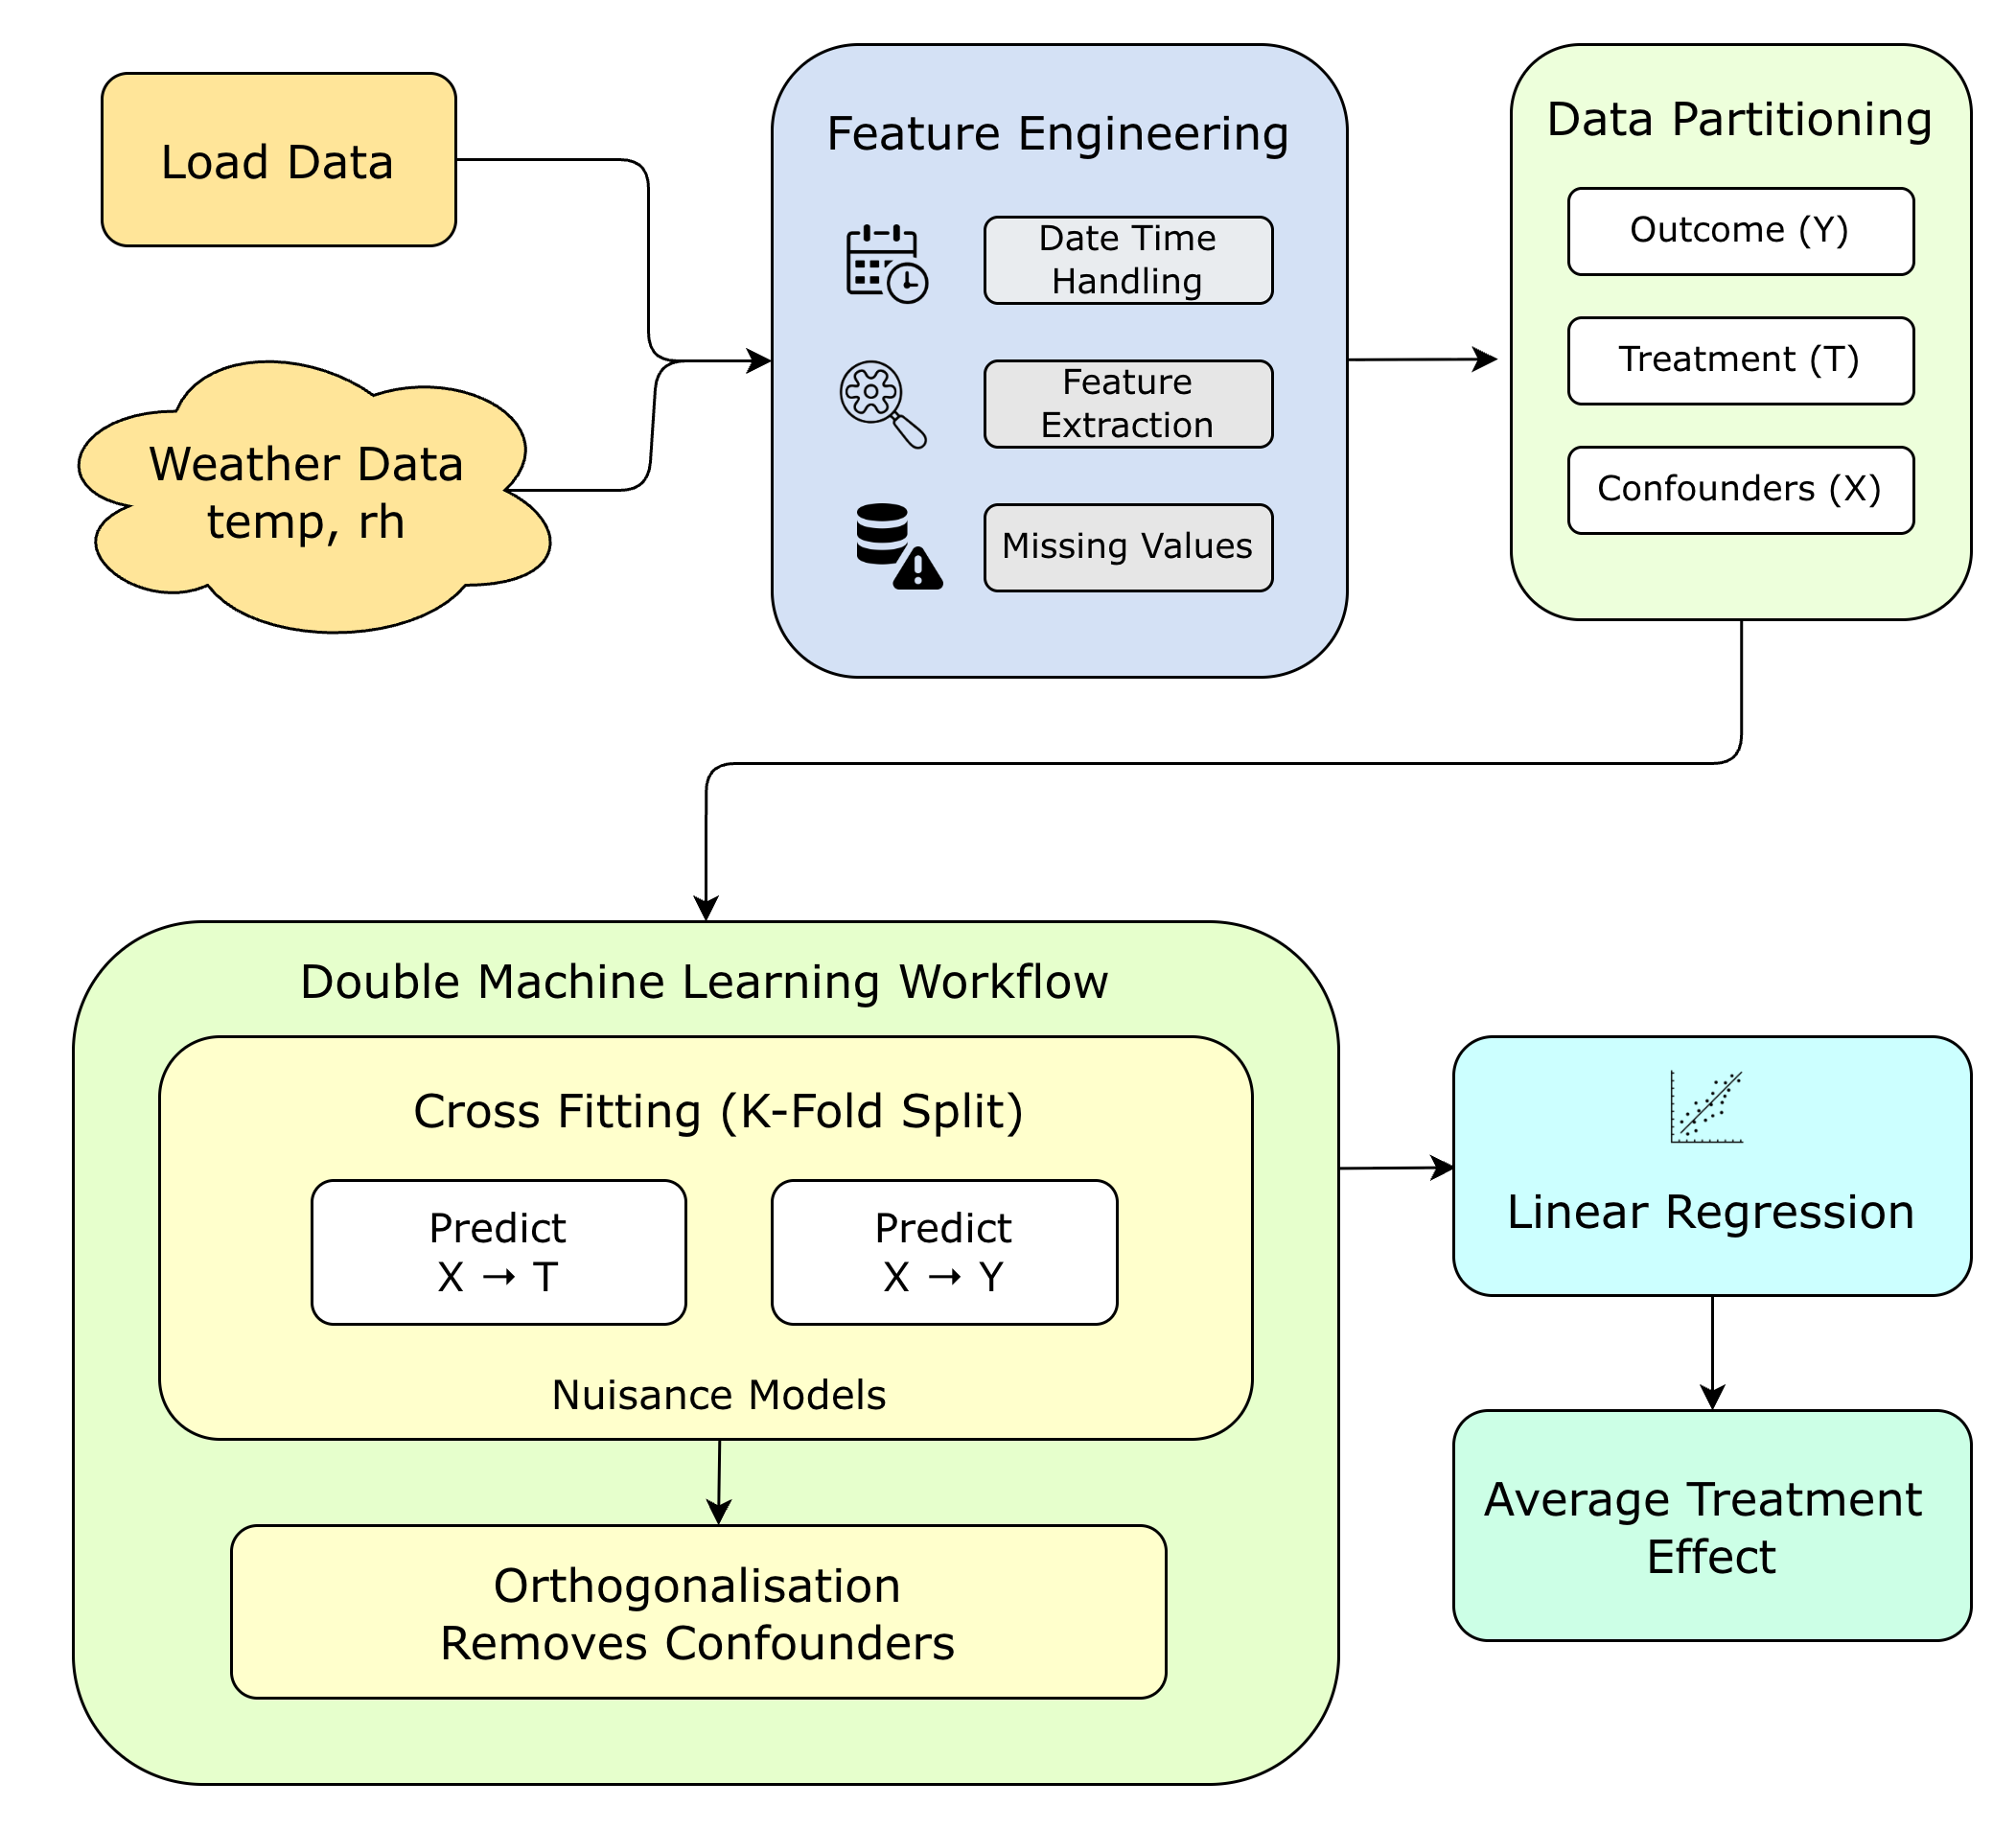
Figure 2.1.2: Double Machine Learning Diagram
As shown in the diagram, the process begins with the input dataset consisting of load as the outcome variable, temperature as the treatment variable, and time-based features such as hour and lag variables as controls. The data is first passed through a K-fold cross-fitting stage, which splits the dataset into multiple folds to reduce overfitting and improve robustness of the causal estimates. After this, the variables are explicitly separated into outcome (Y), treatment (T), and control variables (X). In the next stage, two nuisance models are trained: one predicts the outcome using the control variables, and the other predicts the treatment using the same controls. These models capture the portion of variation explained by confounders. Residuals are then computed by subtracting these predictions from the actual values, resulting in de-confounded representations of both the outcome and treatment. Finally, a regression is performed on these residuals to estimate the causal effect, where the coefficients represent the impact of the treatment variable on electricity load.
It extends traditional random forests to estimate heterogeneous treatment effects [6]. Instead of focusing on prediction accuracy, it constructs trees that split the data based on differences in treatment effects. Each tree partitions the dataset into regions where the relationship between variables differs, allowing the model to capture how the effect of temperature on load changes across different hours. The method also uses an “honesty” principle, where separate data is used for splitting and estimation to reduce bias. Additionally, GRF applies kernel weighting to estimate local effects for specific data points. However, GRF has weaker control over confounding variables compared to DML-based approaches and is primarily designed for univariate treatment settings, meaning it typically handles one treatment variable at a time. In this study, where multiple variables jointly influence electricity load, a multivariate causal framework is required and GRF is not used.
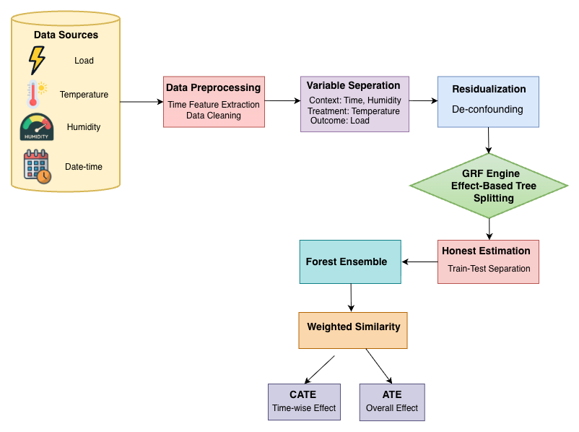

Figure 2.1.3: GRF Diagram
As shown in the diagram, the process starts with input data consisting of load as the outcome, temperature as the treatment, and hour and humidity as covariates. The model partitions the data by maximizing differences in treatment effects, creating regions such as morning, afternoon, and evening. Within each region, local treatment effects are estimated to capture how temperature influences load under specific conditions. To ensure unbiased results, GRF applies the honesty principle by using separate data for splitting and effect estimation. It then aggregates results across multiple trees and assigns weights based on similarity between observations. Finally, the model outputs Conditional Average Treatment Effects (CATE), which vary across conditions, along with the overall Average Treatment Effect (ATE).
To overcome these limitations, the EconML framework integrates the strengths of DML and GRF into a unified approach for causal analysis [7]. EconML first performs orthogonalization using DML to remove the influence of confounding variables such as time. The residualized outcome and treatment variables are then passed to a second-stage model, such as a causal forest, which estimates how treatment effects vary across different conditions. The architecture of EconML can be understood as a layered system consisting of data preprocessing, orthogonalization, causal forest modeling, and inference. This makes it particularly suitable for multivariate scenarios and allows for a deeper understanding of how weather variables influence electricity demand at different times of the day.
EconML further enhances causal analysis by allowing flexible integration of different machine learning models in both the first and second stages. In the first stage, models such as random forests or gradient boosting are used to learn complex patterns between time and the variables, ensuring that non-linear relationships are properly captured. In the second stage, methods like CausalForestDML estimate heterogeneous treatment effects, meaning the impact of temperature on load is not assumed to be constant but varies across different hours and conditions. This flexibility makes EconML highly suitable for real-world datasets like electricity demand, where relationships are rarely purely linear and often depend on contextual factors[7].
Another key advantage of EconML is its ability to provide interpretable and reliable insights through built-in inference mechanisms. It not only estimates the average treatment effect but also enables analysis of how effects change across different time periods, helping identify peak impact hours where weather has the strongest influence on load[7]. Additionally, EconML supports visualization techniques and integration with explainable AI methods, making it easier to communicate results in a meaningful way. This combination of robustness, interpretability, and adaptability makes EconML a powerful framework for understanding weather-driven variations in electricity demand[7].

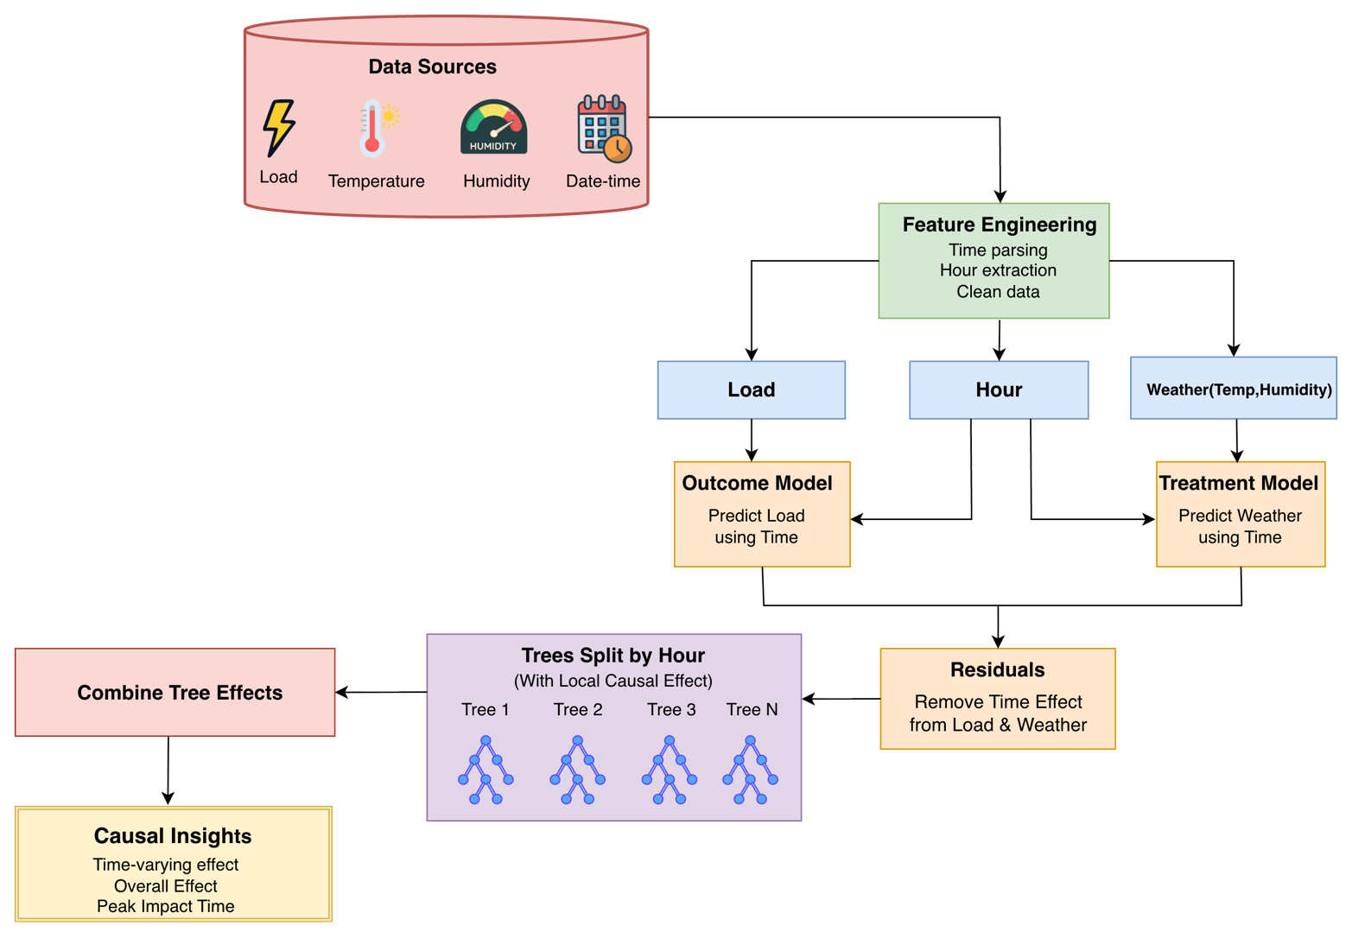
2.1.4: EconML Diagram
As shown in the diagram, the process begins with data preprocessing, including time parsing, hour extraction, and cleaning. The variables are then defined as load (outcome), treatment variables (temperature and humidity), and control variables (such as hour). Two models are trained to predict the outcome and treatment from the control variables, and residuals are computed to remove confounding effects. These residuals are passed into a causal forest, where multiple trees split the data based on hour to capture variations in treatment effects across different time segments. Each tree estimates local causal effects, which are then aggregated across the forest. The final output includes Conditional Average Treatment Effects (CATE) that vary with time, along with overall insights such as average treatment effect, peak impact periods, and temporal variation. This architecture enables multivariate and time-dependent causal analysis, making it well-suited for weather-driven electricity load modelling.
It is a statistical method used to model the relationship between one dependent variable and multiple independent variables in a structured and quantitative manner. This technique helps in understanding how different input variables collectively influence a single output variable. In the context of this study, Multiple Linear Regression (MLR) is applied to estimate how electricity load is influenced by weather-related factors such as temperature and humidity, while also considering the effect of time-related variables like hourly variations and seasonal patterns.
The model assumes that the electricity load can be represented as a linear combination of these independent variables, along with an intercept term that accounts for the baseline load when all variables are zero. By fitting this linear equation to historical data, the model determines coefficients for each variable, which indicate their respective contributions to the overall load. This allows us to quantitatively measure how a unit change in temperature or humidity impacts electricity demand, while keeping other factors constant. As a result, MLR provides a simple yet effective baseline approach for analysing relationships between variables and understanding their combined effect on electricity load behaviour.
In summary, XAI methods such as SHAP and LIME improve interpretability but remain limited to correlation-based insights. DML introduces a robust framework for estimating causal effects but does not capture heterogeneity. GRF addresses heterogeneity but is restricted to univariate treatments. EconML combines these approaches to provide a comprehensive solution for multivariate causal analysis with time-dependent effects. Therefore, it forms the core methodology of this work, enabling both accurate interpretation and causal understanding of weather-driven electricity load.

2.2 State-of-the-Art Research in Explainable AI and Causal Analysis

Table 1: Literature Review
Ref. No | Objective | Approach | Key Findings | Open Issues
[1] | Improve load  forecasting  using causal  relationship | Causal inference +  Informer model | External factors like Weather, GDP, etc. have Causal impact on load | No explainability (black-box output)
[2] | Identify causal weather factors affecting load | Quantile Granger causality + BiLSTM | Selecting causal variables improves accuracy (~30% error reduction) | Limited to statistical causality, no XAI
[3] | Model causal, nonlinear, and uncertain energy patterns. | Causal discovery + Neural operator + Fuzzy logic | Captures complex dynamics; identifies key drivers like temperature and humidity. | No SHAP/LIME; limited interpretability.
[4] | Improve interpretability of load forecasting. | XGBoost + SHAP + LIME + PDP. | Provides reasoning through global and local feature contribution analysis. | No causal inference (only correlation-based).
[5] | Apply DML for causal inference in real-world settings | Residualization, ML regression | Better causal estimation than classical regression methods | Performance depends on correct ML model selection
[6] | Estimate heterogeneous treatment effects | Causal Trees, Random Forests, Honesty Principle | Captures nonlinear and heterogeneous causal effects effectively | Requires tuning; limited interpretability
[7] | Apply causal ML in real industrial systems | DML, Meta-learners, Orthogonalization, EconML framework | Improves causal effect estimation and decision-making | Needs strong assumptions, high computation, sensitive to data quality
[8] | Estimate causal effects in high-dimensional systems | Orthogonalization, Cross-fitting, ML models | Provides unbiased causal estimates under complex ML settings | Sensitive to nuisance model selection, computationally expensive
[9] | Explain deep learning-based load forecasting. | LSTM + multi-task learning + SHAP. | Combines cause-effect analysis, explainability, and natural language insights. | No causal analysis.
[10] | Analyze how XAI is applied in energy systems. | Systematic review of ~50 studies across models, data, and users. | SHAP is the dominant method; emphasizes need for user-centric . | Lacks standardized evaluation metrics and real-world deployment.
[11] | Enhance load forecasting accuracy using multiple variables. | LSTM/Bi-LSTM models with weather inputs + LIME. | Weather variables significantly influence load predictions; improved accuracy. | Uses less stable XAI (LIME); does not include causal analysis.
[12] | Develop explainable deep learning for accurate forecasting. | Transformer + KAN + attention mechanisms. | High accuracy; provides interpretable feature relationships through model. | High model complexity; lacks causal interpretation.
[13] | Improve the reliability of XAI explanations. | Optimizing SHAP background data selection in time-series context. | Explanation accuracy depends heavily on background context. | Does not address causal relationships; lacks operational validation.
[14] | Explainable household energy forecasting. | Hybrid Transformer + BiLSTM + SHAP + Bayesian optimization. | Hybrid model improves accuracy; SHAP shows temperature and weather are important. | No causal inference; mostly predictive.
[15] | Explainable electricity demand prediction. | LSTM + Transformer + SHAP. | High accuracy; identifies impact of temperature and humidity. | No causal modeling; correlation-based.
[16] | Transfer learning + XAI for heat load forecasting. | TL + LSTM/Transformer + SHAP. | Transfer learning improves performance; SHAP adds feature importance. | No causal inference.
[17] | Explainable hybrid time-series forecasting. | CNN + Entropy + SVR + SHlAP/LIME. | High accuracy; uses LIME and SHAP plots for feature importance. | No causal inference.
[18] | Explainable DL for stock trends. | Deep NN + SHAP + LIME. | High accuracy and feature importance. | No causal inference.
[19] | Explainable residential load forecasting. | LSTM-based time-series model + SHAP. | Weather and past load strongly influence predictions. | Only correlation-based; no causal inference.
[20] | Explainable and weather-independent day-ahead forecasting. | CART-based segmentation + MLR/GPR + GLSAR + SHAP. | Explains calendar effects and lag features. | Correlation-based; no causal inference.
[21] | Interpretable deep learning for power load. | CNN + GRU + SHAP. | CNN-GRU improves accuracy; SHAP shows temperature/time features influence load. | Only correlation-based; no causal inference.

Chapter 3
Proposed System
To address the problem effectively, this project adopts a structured and explainable approach using causal machine learning techniques. The proposed methodology integrates both advanced causal modeling through EconML and traditional mathematical methods to ensure accurate, interpretable, and reliable results. The approach is designed in a phase-wise manner, starting from data acquisition to final performance evaluation.

The overall workflow of the system is illustrated in Figure 3.1: Proposed Approach. The approach consists of multiple stages that systematically transform raw data into meaningful insights. It begins with data acquisition, where relevant data is collected, followed by data preprocessing to clean and prepare the dataset. In the next step, important variables such as treatment, outcome, and confounders are defined for causal analysis. The system then follows two parallel approaches: the EconML-based causal model and the mathematical/statistical approach for comparison. Finally, the results from both approaches are evaluated using performance metrics to ensure accuracy and reliability of the model.

The process begins with data acquisition, where relevant datasets are collected from reliable sources such as databases or online repositories. The data must be complete, accurate, and suitable for analysis, as the quality of input data directly affects the results. In the next phase, the collected data is cleaned and prepared for further processing. Missing values are handled, noise is removed, and the data is transformed into a structured format. This step ensures that the dataset is consistent and ready for analysis
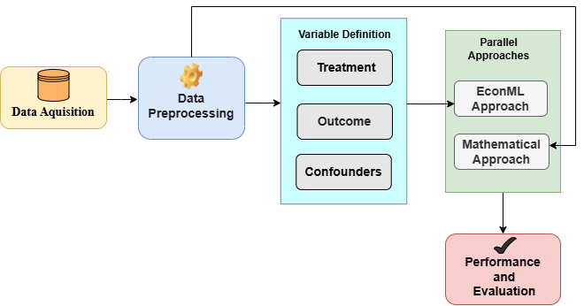
Figure 3.1: Proposed Approach
Key variables required for causal analysis are defined. The Treatment variable represents the influencing factor, the Outcome variable represents the result, and Confounders are identified as variables affecting both. The proper definition of these variables is essential for accurate causal inference.

The system utilizes a dual-track methodology to enhance the reliability of its findings. Once the variables are defined, it concurrently executes two distinct strategies: the EconML approach, which leverages advanced causal machine learning models to estimate treatment effects with high precision, and the Mathematical approach, which utilizes traditional statistical methods like regression to establish a solid baseline. By running these processes in parallel, the system allows for a rigorous cross-comparison of results, ensuring that the final causal inferences are both validated and robust before moving to the evaluation phase.

Following the parallel execution of both approaches, the system proceeds to a comprehensive evaluation stage where the outputs are systematically compared using standard performance metrics such as Mean Absolute Error (MAE), Root Mean Squared Error (RMSE), and Mean Absolute Percentage Error (MAPE). This evaluation not only measures prediction accuracy but also validates the consistency of causal relationships identified by the models. By comparing the results obtained from the EconML-based causal framework and the traditional mathematical model, the system ensures that the derived insights are both statistically sound and causally meaningful.

In addition to quantitative evaluation, the framework incorporates Explainable Artificial Intelligence (XAI) techniques such as SHAP and LIME to enhance interpretability. These methods provide both global and local explanations of model behavior, helping to identify the contribution of each variable to the predicted outcomes. This integration of explainability with causal inference enables a deeper understanding of how weather variables influence electricity load, thereby supporting more transparent, reliable, and informed decision-making in energy demand analysis.

Chapter 4
Implementation Details and Results
Following the proposed causal and mathematical modeling framework, this section presents the implementation details, including data characteristics, experimental setup, and evaluation methodology used to validate the approach.
4.1 Data Characteristics
The dataset used in this study consists of real-time electricity load and weather data obtained from Tata Power. It is structured as a time-series dataset where each record corresponds to a timestamped observation of electricity demand along with associated meteorological variables. The data includes key attributes such as electricity load (wdLoad), temperature (temp), and relative humidity (rh), along with a timezone-aware datetime field.
The data is recorded at a 15-minute resolution, as observed from the timestamp intervals (e.g., 00:00, 00:15, 00:30, 00:45), allowing for high-frequency analysis of load variations. This fine-grained temporal resolution enables the capture of short-term fluctuations in electricity demand as well as rapid changes in weather conditions. The presence of continuous timestamps ensures proper sequential modelling and supports the derivation of additional temporal features such as hour of the day.
The dataset spans two development–validation cycles, namely November 2023 to November 2024 and November 2024 to November 2025. The first cycle is used for estimating causal effects and deriving model parameters, while the second cycle is used for validating the generalization of the proposed approach. To account for seasonal variability, the data is segmented according to Indian Meteorological Department (IMD) seasonal classifications, including Winter, Summer, Monsoon, and Autumn. This segmentation enables season-specific analysis of the relationship between weather variables and load demand.

4.2 Experimental Setup
4.2.1 Tools and Libraries
The implementation was carried out using Python in a notebook-based environment such as Google Colab or Jupyter Notebook. Various libraries were utilized to support different stages of the workflow. For data processing and manipulation, pandas and numpy were used. Machine learning tasks were implemented using scikit-learn, while causal inference was performed using EconML. Explainable AI techniques were applied using SHAP and LIME to interpret model behaviour. Additionally, visualization of results and insights was performed using matplotlib and seaborn.
4.2.2 Training and Testing Methodology
A holdout validation strategy was adopted for the experimental setup. The 2024 dataset was used for training purposes, where it served to learn causal effects using EconML, derive mathematical (MLR-based) equations, and train XAI models. The 2025 dataset was reserved for testing and validation, where it was used to evaluate the performance of the derived causal equations and assess the generalization capability of the models across different seasons.

4.2.3 Hyper-Parameters
Table 2: Hyperparameters of EconML
Parameter | Value
Model_Y | max_depth=5, n_estimators=100
Model_T | max_depth=5, n_estimators=100
Random State | 42
CV Folds | 5

4.2.4 XAI Based Approach
To ensure model transparency, we implemented an Explainable AI (XAI) framework. We applied LIME (Local Interpretable Model-agnostic Explanations) and SHAP (SHapley Additive exPlanations) to a Linear Regression model trained on the 2024 dataset. While LIME provided local explanations for specific load spikes, SHAP was utilized to quantify the global importance and contribution of Temperature and Relative Humidity (RH) across the entire yearly cycle. This step served to validate that the features used in the subsequent causal analysis were indeed the primary drivers of demand.

4.2.5 EconML Based Approach
The EconML framework estimate the Average Treatment Effect (ATE) and Heterogeneous Treatment Effects (HTE). The ATE represents the average change in the outcome variable (electricity load) due to a unit change in a treatment variable (temperature or humidity), while HTE captures how this effect varies across different conditions such as time of day or season.

4.2.6 Mathematical Approaches

  - Multiple Linear Regression
We implement the Multiple Linear Regression model as defined in Eq. (1), Eq. (2), Eq. (3), Eq. (4)

$$\begin{aligned}β_{1} = \frac{\left(\sum_{ }^{ }{x_{2}^{2}}\right)\left(\sum_{ }^{ }{x_{1}y}\right)-\left(\sum_{ }^{ }{x_{1}x_{2}}\right)\left(\sum_{ }^{ }{x_{2}y}\right)}{\left(\sum_{ }^{ }{x_{1}^{2}}\right)\left(\sum_{ }^{ }{x_{2}^{2}}\right)-{\left(\sum_{ }^{ }{x_{1}x_{2}}\right)}^{2}}\#(1)\end{aligned}$$

$$\begin{aligned}β_{2} = \frac{\left(\sum_{ }^{ }{x_{1}^{2}}\right)\left(\sum_{ }^{ }{x_{2}y}\right)-\left(\sum_{ }^{ }{x_{1}x_{2}}\right)\left(\sum_{ }^{ }{x_{1}y}\right)}{\left(\sum_{ }^{ }{x_{1}^{2}}\right)\left(\sum_{ }^{ }{x_{2}^{2}}\right)-{\left(\sum_{ }^{ }{x_{1}x_{2}}\right)}^{2}}\#(2)\end{aligned}$$

$$\begin{aligned}β_{0 }= \overline{y} - \overline{x_{1}} β _{1} - {\overline{x_{ }}}_{2} β_{2}\#(3)\end{aligned}$$

$$\begin{aligned}\hat{y} = β_{0} + β_{1}x_{1} + β_{2}x_{2}\#(4)\end{aligned}$$
Where:
$y →$Actual Load
$\hat{y} →$Predicted Load
$x_{1}, x_{2 } →$Temperatuer and Humidity Respectively
$β_{0} →$Intercept
$β_{1}, β_{2} →$Regression Coefficient
  - Coefficient Based Mathematical Derivation
The model coefficients were estimated using the EconML framework. Based on these derived values, the governing equation for the system is defined using Eq. (5)
$\begin{aligned}Y_{t} = Y_{t-1} + β_{1 }\left(x_{1,t} - x_{1,t-1}\right) + β_{2}\left(x_{2,t} - x_{2,t-1}\right)\#(5)\end{aligned}$
Where:
$Y_{t}→$ Predicted Load at current time stamp
$Y_{t-1}→$ Actual Load at previous time stamp
$x_{1,t}→$ Temperature at current time
$x_{1,t-1}→$ Temperature at previous time
$x_{2,t}→$ Temperature at current time
$x_{2,t-1}→$ Humidity at previous time
$β_{1},β_{2}→$ Causal Coefficient of Temperature and Humidity respectively

4.3 Evaluation Metrics
The performance of the proposed model is evaluated using three standard regression metrics: Mean Absolute Error (MAE), Root Mean Squared Error (RMSE), and Mean Absolute Percentage Error (MAPE). These metrics provide a comprehensive assessment of prediction accuracy by capturing different aspects of error between the actual and predicted load values.

4.3.1 Mean Absolute Error (MAE)
It measures the average magnitude of errors in a set of predictions, without considering their direction, as shown in Eq. (6)
$\begin{aligned}MAE= \frac{1}{n}\sum_{i=1}^{n}{\left|y_{i} - \hat{y_{i}}\right|}\#(6)\end{aligned}$
Where:
$y_{i}→$ Actual Load
$\hat{y}→$ Predicted Load
$n→$ Total number of observations

4.3.2 Root Mean Square Error (RMSE)
The square root of the average of squared differences between prediction and actual observation, as shown in Eq. (7)
$\begin{aligned}RMSE= \sqrt{\frac{1}{n}\sum_{i=1}^{n}{{\left(y_{i }-\hat{y_{i}}\right)}^{2}}}\#(7)\end{aligned}$
Where:
$y_{i}→$ Actual Load
$\hat{y}→$ Predicted Load
$n→$ Total number of observations

4.2.3 Mean Absolute Percentage Error (MAPE)
We use MAPE to calculate, the average of the absolute percentage errors, as shown in Eq. (8)
$\begin{aligned}MAPE= \frac{100}{n}\sum_{i=1}^{n}{\left|\frac{y_{i }- \hat{y_{i}}}{\hat{y_{i}}}\right|}\#(8)\end{aligned}$
Where:
$y_{i}→$ Actual Load
$\hat{y}→$ Predicted Load
$n→$ Total number of observations

Chapter 5
Result and Discussion
The effectiveness of the proposed framework is evaluated using the defined metrics, and the results are systematically analyzed and discussed in the following section to highlight performance differences across approaches and seasons.
5.1 XAI Outcomes
- Shap Summary Plot
Below is a SHAP summary (beeswarm) plot, which shows global feature impact across all samples
Figure 5.1.1 suggests that temperature (temp) is the dominant feature affecting the model output, while humidity (rh) has very little impact overall.

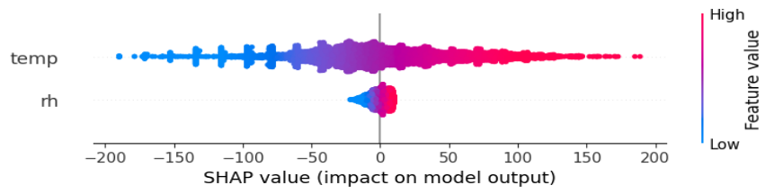
Figure 5.1.1 : SHAP Summary Plot
- SHAP Waterfall Plot
SHAP waterfall plot explains how your model arrived at a single prediction.
Figure 5.1.2 explains temperature dominates and Humidity is a secondary factor.
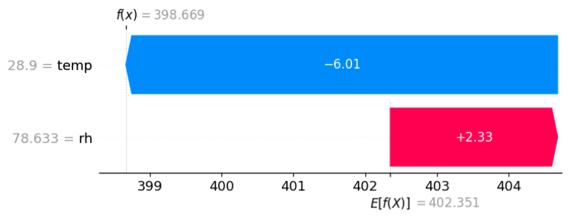

Figure 5.1.2 : SHAP Waterfall Plot
- LIME Explanation
It is used to explain why a machine learning model made a specific prediction for a single data point.
Figure 5.1.3 shows that the predicted value is primarily influenced by temperature, which significantly reduces the output, while humidity contributes a minor positive effect.
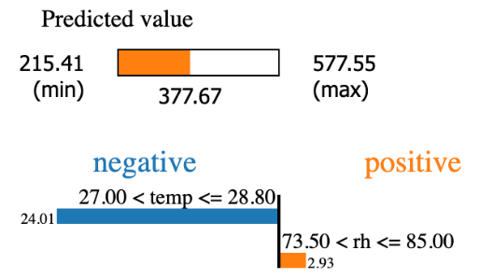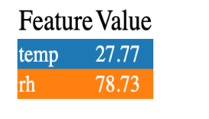
Figure 5.1.3 : LIME Explanation

5.2 ML Based Causal Approach
The implementation of EconML for load forecasting represents a shift from traditional predictive modeling to a causal inference framework. By calculating the Average Treatment Effect (ATE), the model determines how much the electrical load will actually change for every unit increase in temperature or relative humidity, while simultaneously "denoising" the influence of other confounding factors. This method is applied on the data available for year 2024 and according to IMD defined seasons.

Table 3: ATE Values per season
Season | ​​ATE (Temp → Load)​ | ​​ATE (RH → Load)​
Winter | 4.1565 | 1.1928
Summer | 11.9615 | 1.3358
Monsoon | 6.8046 | -0.5083
Autumn | 6.7054 | 0.8443

Below are the season-wise results show that effects vary across hours, indicating heterogenous (time-varying) causal relationships, between weather variables and electricity load.

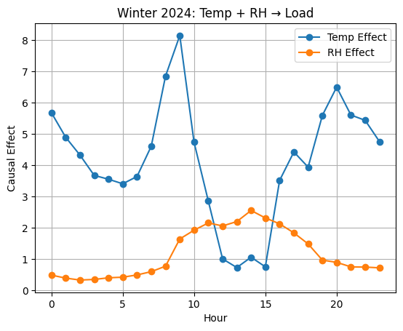
Figure 5.2.1 : Winter 2024: Temp & RH Impact on Load (Hourly)

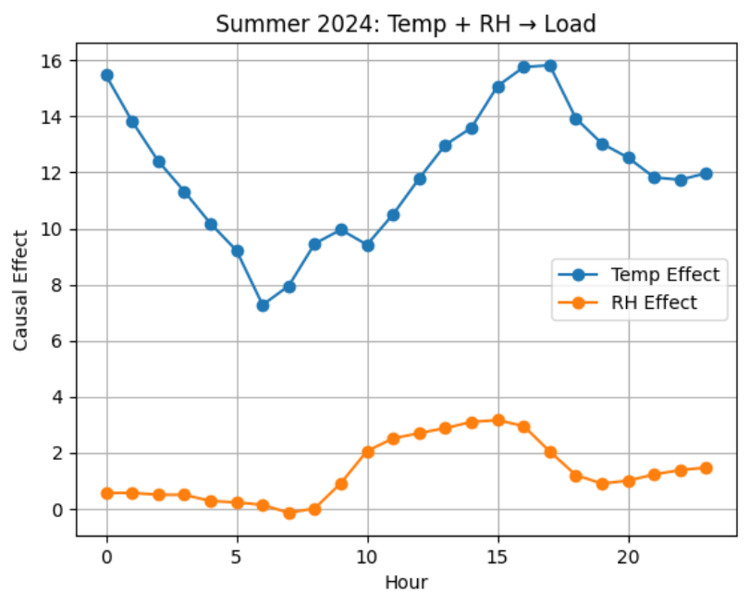
Figure 5.2.2 : Summer 2024: Temp & RH Impact on Load (Hourly)
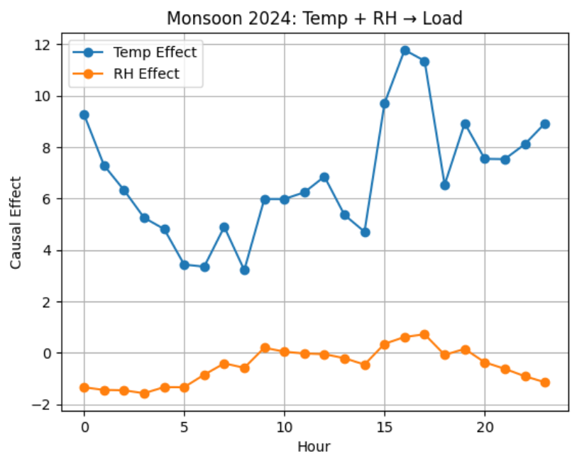
Figure 5.2.3 : Monsoon 2024: Temp & RH Impact on Load (Hourly)

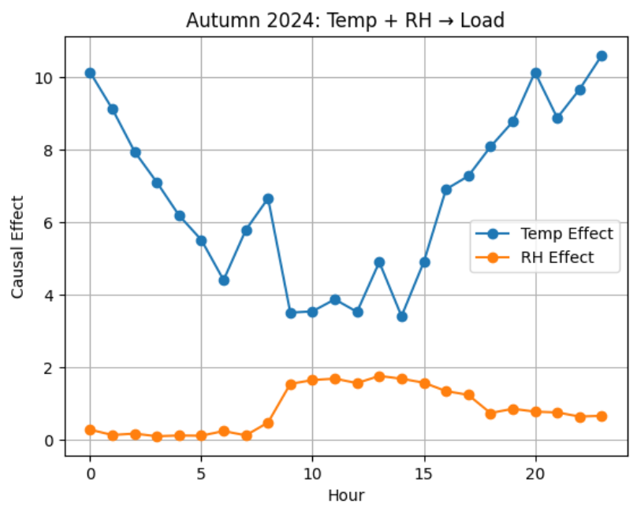

Figure 5.2.4 : Autumn 2024: Temp & RH Impact on Load (Hourly)
5.3 Mathematical Correlation Based Approach
Our methodology involved utilizing 2024 historical data to derive season-specific load prediction equations through two distinct statistical lenses: Multiple Linear Regression (MLR) and EconML Causal Inference. In the first approach, we manually performed an MLR to determine coefficients based on historical correlation, creating a static mathematical baseline for each season. Simultaneously, we used EconML's Double Machine Learning framework on the same 2024 data to derive Average Treatment Effect (ATE) coefficients, which isolate the true causal impact of temperature and humidity changes on load. To validate their robustness, these 2024-derived equations were then tested against the unseen 2025 seasonal datasets
5.3.1 Results for equation based EconML
Table 4 : EconML Equation Performance
Season | MAE | RMSE | MAPE (%)
Winter | 4.6237 | 6.0503 | 1.23%
Summer | 4.6541 | 6.2405 | 1.06%
Monsoon | 5.1754 | 6.8076 | 1.20%
Autumn | 4.8304 | 6.2549 | 1.14%

5.3.2 Mathematical Approach (Multiple Linear Regression)
Table 5 : MLR Performance
Season | MAE | RMSE | MAPE
Winter | 51.298 | 62.01 | 12.66%
Summer | 59.371 | 75.8168 | 12.21%
Monsoon | 78.7931 | 99.8375 | 16.29%
Autumn | 62.521 | 80.1818 | 13.21%
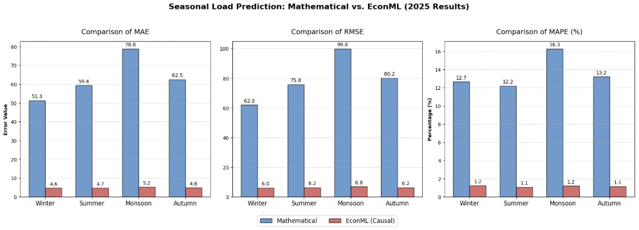

Figure 5.3.1 : Performance Comparison (Mathematical vs EconML Approach)

Chapter 6
Conclusion and Future Work
The proposed system establishes a strong foundation for accurate and interpretable predictions, and its future enhancements through the inclusion of additional variables and improved explainability can further strengthen its robustness, adaptability, and real-world applicability.

6.1 Conclusion
This project presents the development of an Explainable AI and causal inference-based framework to analyze the impact of weather variables on electricity load. It addresses a key limitation of traditional forecasting methods, which primarily rely on correlation-based learning and lack interpretability. By introducing a more advanced analytical approach, the study ensures that the relationships identified are not only accurate but also meaningful and understandable, making the model more reliable for real-world applications.

The proposed framework integrates three major components: Explainable AI techniques such as SHAP and LIME, causal machine learning using EconML, and traditional statistical modeling through Multiple Linear Regression (MLR). This combination creates a dual-track system that enables both interpretation and validation of results. While SHAP and LIME help in understanding feature importance, EconML ensures causal relationships, and MLR serves as a baseline for comparison, strengthening the overall analysis.

The experimental results clearly show that the EconML-based model outperforms the traditional MLR approach across different seasons. The Mean Absolute Percentage Error (MAPE) for EconML is significantly lower, around 1–1.2%, compared to 12–16% for MLR, indicating higher prediction accuracy and robustness. Additionally, SHAP and LIME analysis reveal that temperature is the most influential factor affecting electricity load, while humidity has a comparatively smaller but still notable impact.

Furthermore, the causal analysis highlights important seasonal and time-dependent variations in the influence of weather variables, along with heterogeneous effects during peak hours and summer periods. By accounting for confounding factors such as time, the model produces more reliable insights. Overall, the integration of causal inference with explainable AI enhances prediction performance, improves interpretability, and provides trustworthy, actionable insights, making the framework highly suitable for smart energy management and electricity demand forecasting systems.

6.2 Future Work
In the future, the proposed approach can be extended by incorporating a wider range of influencing variables to improve its robustness and practical relevance. Factors such as wind speed, rainfall, and solar radiation can be included alongside economic indicators like GDP and levels of industrial activity, as well as consumer behavior and demand patterns. Considering these diverse parameters would allow the model to better capture real-world complexities, leading to improved predictive accuracy and a deeper, multi-dimensional understanding of the underlying relationships. By combining environmental, economic, and behavioral data, the model can move beyond simple predictions toward a more holistic and multi-dimensional understanding of the problem domain. This enhancement would not only improve predictive accuracy but also strengthen the model’s ability to generalize across different scenarios and conditions. Furthermore, the framework can be enhanced by focusing on explainability through the integration of advanced large language models. These models can generate clear and meaningful natural language explanations of predictions, making the system more transparent and interpretable.

Chapter 7
References
[1] J. Zhang et al., "Medium- and Long-Term Load Forecasting Based on Causal Inference and Informer," Applied Sciences, vol. 13, no. 13, p. 7696, MDPI, July 2023. [Online]. Available: https://doi.org/10.3390/app13137696
[2] A. Author et al., "Load Forecasting Using BiLSTM with Quantile Granger Causality," Applied Sciences, vol. 15, no. 11, p. 5912, MDPI, June 2025. [Online]. Available: https://doi.org/10.3390/app15115912
[3] S. Raza et al., "Causal-Fuzzy Neural Operators for Smart Energy Forecasting," Energy Reports, vol. 11, pp. 1089–1106, Elsevier, Jan. 2025. [Online]. Available: https://doi.org/10.1016/j.egyr.2025.108946
[4] M. Khan et al., "Explainable AI Framework Using XGBoost with SHAP & LIME," IEEE Access, vol. 13, pp. 36026–36040, IEEE, Feb. 2025.
[5] M. Knaus, “Double machine learning based program evaluation under unconfoundedness,” arXiv preprint, 2020. https://arxiv.org/abs/2003.03191
[6] S. Athey, J. Tibshirani, and S. Wager, “Generalized random forests,” Annals of Statistics, vol. 47, no. 2, pp. 1148–1178, 2019. https://arxiv.org/abs/1610.01271
[7] V. Syrgkanis et al., “Causal Inference and Machine Learning in Practice with EconML and CausalML: Industrial Use Cases at Microsoft, TripAdvisor, Uber,” Proc. ACM SIGKDD Int. Conf. Knowl. Discov. Data Mining (KDD), 2021. doi: 0.1145/3447548.3470792
[8] V. Chernozhukov et al., “Double/debiased machine learning for treatment and structural parameters,” The Econometrics Journal, vol. 21, no. 1, pp. C1–C68, 2018. https://arxiv.org/abs/1608.00060
[9] L. Machina et al., "Explainable Framework for Load Forecasting," Energy Systems, vol. 13, no. 2, pp. 245–267, Springer, Oct. 2022.
[10] G. J. Tso et al., "A Four-Dimensional Analysis of Explainable AI in Energy Forecasting," Machine Learning and Knowledge Extraction, vol. 7, no. 4, pp. 153–175, MDPI, Dec. 2025.
[11] K. Simov et al., "A Multivariate Time Series Analysis of Electrical Load Forecasting with XAI," Applied Sciences, vol. 13, no. 23, p. 12946, MDPI, Nov. 2023.
[12] X. Zhou et al., "KAN-Based Explainable Transformer for Load Forecasting," Sustainability, vol. 18, no. 3, p. 1677, MDPI, Feb. 2026.
[13] H. Müller et al., "Contextual Background Estimation for XAI in Load and Temperature Forecasting," Applied Sciences, vol. 15, no. 3, p. 1057, MDPI, Jan. 2025.
[14] S. Ahmed et al., "Explainable multivariate household energy forecasting using weather data," Energy and AI, vol. 16, Elsevier, Mar. 2026.
[15] R. Kumar et al., "Explainable deep learning approach to predict residential electricity demand," Journal of Control, Automation and Electrical Systems, vol. 36, no. 1, pp. 282–300, Springer, Feb. 2025.
[16] J. Li et al., "Transfer learning and explainable AI for heating load forecasting," Energy and AI, vol. 17, Elsevier, Jan. 2026.
[17] T. Wang et al., "DCEnt-PredictiveNet: A novel explainable hybrid model," Neurocomputing, vol. 580, pp. 128389, Elsevier, Aug. 2024.
[18] M. Gupta et al., "An explainable deep learning approach for stock market trend prediction," Heliyon, vol. 10, no. 12, p. e40095, Elsevier, June 2024.
[19] O. Nord et al., "Electrical Load Forecasting Utilizing XAI on Norwegian Residential Buildings," in Proc. 2022 Int. Conf. Smart Energy Systems and Technologies (SEST), 2022. doi: 10.1109/SEST53650.2022.9898500.
[20] F. Chen et al., "Daily Load Forecasting Using Explainable AI-Driven Method," IEEE Access, vol. 13, pp. 36408–36422, IEEE, Mar. 2025.
[21] Y. Sato et al., "Interpretable power load forecasting model based on CNN GRU and SHAP," in Proc. 2023 Int. Conf. Intelligent Informatics and Biomedical Sciences (ICIIBMS), 2023.
[22] D. Lee et al., "Day-ahead Load Forecasting using Explainable AI," in Proc. 2022 IEEE Power & Energy Society Innovative Smart Grid Technologies Conf. (ISGT), 2022.
[23] P. Silva et al., "Toward explainable electrical load forecasting of buildings," Sustainable Energy Technologies and Assessments, vol. 54, Elsevier, Dec. 2022.
[24] K. Park et al., "Explainability and Interpretability in Electric Load Forecasting," Energy and AI, vol. 14, Elsevier, Dec. 2024.
[25] J. Doe et al., "Explainable AI-Enhanced Energy Forecasting Using LightGBM," in Proc. 2025 Global Tech. Congress (GTDASIA), 2025. doi: 10.1109/GTDASIA60461.2025.11313274.

